Ideation Phase

Empathize &amp; Discover

Date | 26 September 2026
Team ID | SWTID-2026-9430
Project Name | AI BlogNest API
Maximum Marks | 4 Marks

Empathy Map Canvas – AI BlogNest

*An empathy map is a simple and easy-to-understand visual tool that helps capture a user’s thoughts, feelings, behaviours, and attitudes.
*For the AI BlogNest project, the empathy map helps the team understand the needs and expectations of users who create, explore, and manage AI-generated blog content.
*Creating this map allows the team to view the platform from the user’s perspective and identify their goals, needs, challenges, and expectations. This helps in designing a more useful and user-friendly blogging experience.

Example:

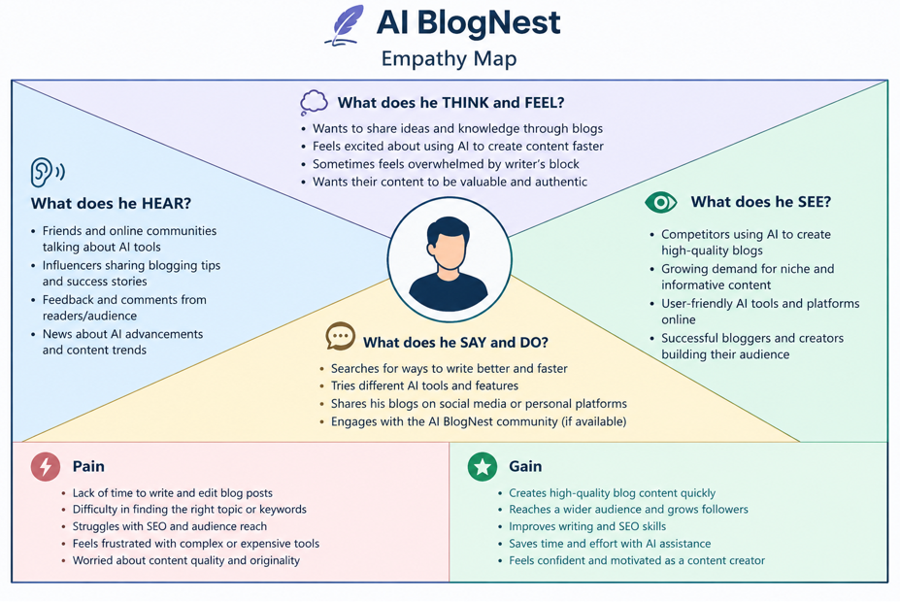

Reference: https://www.mural.co/templates/empathy-map-canvas

Example: Food Ordering &amp; Delivery Application

